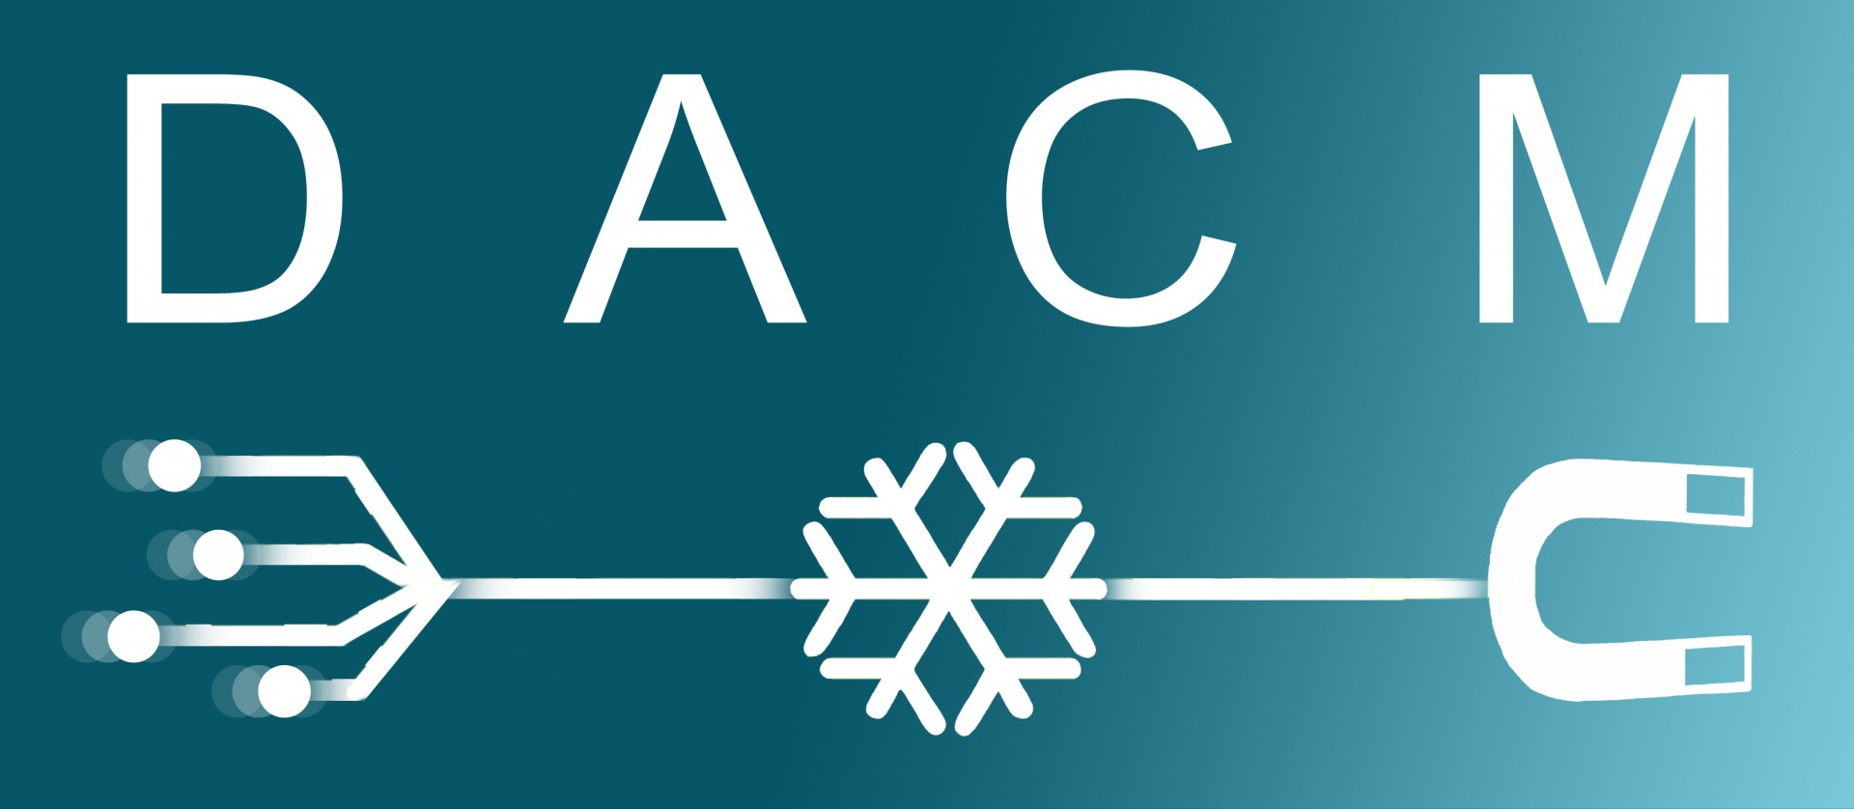
Position to be filled: Post-Doc Laser-Plasma Acceleration
Contract of two years, to be filled immediately
DACM: The Department of Accelerators, Cryogenics and Magnetism is a major national and international player in the field of particle accelerators. It has actively participated in most of the accelerator projects of the world's major research centers over the last decades. Its activities cover the study and manufacture of high intensity ion sources, and the design of linear or circular accelerators for high energy physics or any other scientific application. The accelerator physics requires in-depth knowledge of the beam dynamics in order to control it perfectly.
It is in this field that DACM wishes to reinforce its teams, with an orientation towards new techniques of laser-plasma acceleration. The objective is to develop a program of studies by numerical simulations for the design of a Future Electron Laser-Plasma Accelerator (FALPE), which can support the multiple international projects of laser-plasma accelerator, on which DACM is requested to participate.

DACM is looking for a plasma physicist with skills in radiation-matter modeling and/or particle accelerator physics. You will be in charge of beam dynamics modeling and design of laser-plasma accelerators.
You will be responsible for the development of codes and models and may participate in the design and testing phases at Saclay as well as on-site implementation of accelerator elements in the context of local, national and international projects. You will report on your work by writing reports and articles. You will participate in and organize meetings of teams of physicists, engineers and technicians, or collaboration meetings with French and foreign partner laboratories. You will also ensure the quality and documentation of the work performed.
Missions in France and abroad are to be expected.

Profile: You have an initial training in engineering school or university in plasma physics and a PhD in physics.
You have professional experience in the field of laser-plasma acceleration; experience in PIC simulations in laser-plasma interaction; you know how to handle code and program (Python, C++, Fortran,…); experience in high performance computing HPC and parallel programming.
You are willing to quickly learn beam dynamics physics as an integrated discipline. This training will be delivered within our teams; you wish to work on international laser-plasma accelerator projects.
You are strongly interested in theoretical questions and numerical simulations but leading to concrete and immediate applications; you have a strong interest in particle accelerator physics.
You have a good level of English, oral and written, for writing reports or publications in scientific journals as well as speaking at national or international conferences; you are rigorous, methodical and autonomous; you have the ability to organize teamwork with internal or external PhD students / physicists. Collaborative work and project management are indeed two important parts of the activities.
You have the ability to work in a multidisciplinary context

Contacts: damien.minenna@cea.fr, phu-anh-phi.nghiem@cea.fr
Please send your applications with a cover letter, CV, list of publications, and at least one letter of recommendation.

